Perception
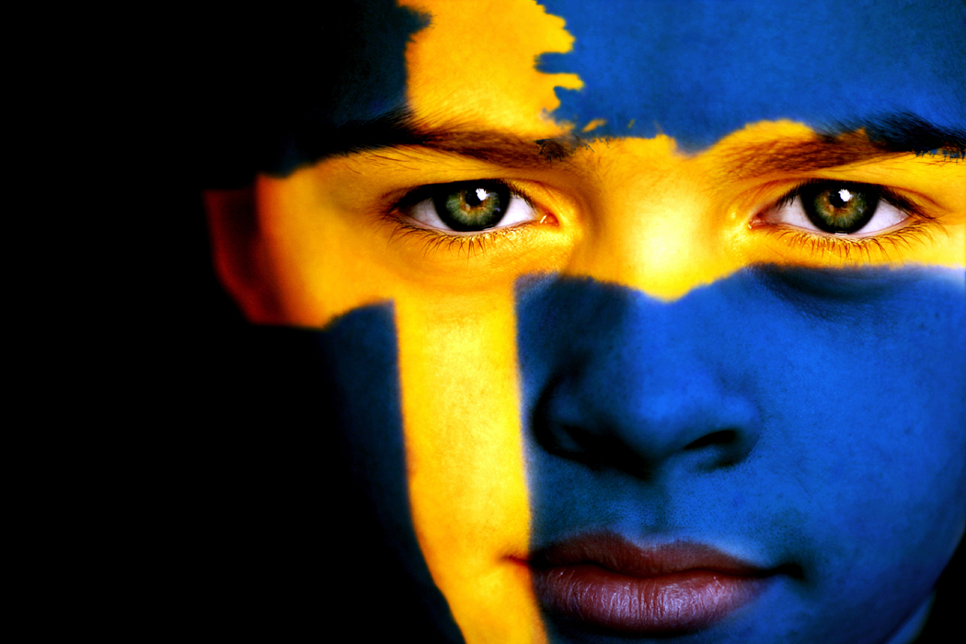
[The Art of Really Seeing]

1. [Picture 1] What do you see?

2. [Picture 2] What do you see?

3. How do “frames” affect or influence our perception of the world?

4. A. What feeling or mood does Van Gogh’s painting evoke? B. Did the reframing change
your perception?

- B.

5. Is the glass half full or half empty?

6. Now, is the glass half full or half empty?

7. (Fill in the blanks.) Perception is _______________ and ________________. Perception is

NOT ________________ and _______________.

8. [Picture 3] What do you see?

9. Seeing both images in picture 3 proves that perception is a ___________ act.

10. [Picture 4] What do you see, if anything?

11. [Picture 5] What do you see, if anything?

12. The married couple says that their partner has changed, but friends say they are both pretty much the same and haven’t changed much, if at all. Yet, both members of the couple want a divorce. Based on the evidence given, what probably has happened?

13. List 3 examples of historical people who have “removed their glasses” and eventually convinced others that their perception was correct.

- B. C.

14. [Nature Walk] Why is education important?

15. [Sheep] What tends to happen when one is unfamiliar with a specific group of people?

16. [Dice] Which group of dice has the fewest members?

17. & 18. What is the rule of proximity? [There are two definitions.]

A.

B.

19. The law of closure explains that we see _________ we __________, instead of

__________ is __________ __________.

20. What’s wrong with the headline, if anything?

21. A. Is the girl likeable or unlikable? B. Why?

A. B.

22. A. Is the boy flabby or muscular? B. Why?

A. B.

23. Comparing the two photos, write down any differences that you see.

24. Regarding one’s own perception, what is the BIGGEST mistake most people make?

25. Explain how knowing the answer to #24 above can help you. (List at least 2 ways.)

